Online Library

Team members: Gulkhayokhon Tulasheva (u1610074)
Nasibakhon Elchieva (u1610164)

Repository link: https://github.com/iuthub/design-project-twin-2

ONLINE LIBRARY
The library.uz the web page where users can download the book which they like. They also can search a book by their name and can download if the book is existed. The web page is very easy to understand. There are all book types in the left side and it helps user easily to find book by types. Also user can read a short information about book. Admin can add book and book type to the web page.

Structure of our web page.
Online library

All books
Admin
About
Home
Search
Information about web page
Search book
Add book
New books
Books and download
Add type
Books

Figure 1. Structure of web page

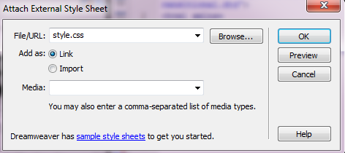
Figure 2. Connecting PHP with CSS
Style.css is our CSS document. Here if we press the button OK the PHP and CSS documents will be connected. We can check it by writing the <link href="style.css" rel="stylesheet" type="text/css" /> between the tags <head> </head> of PHP document.
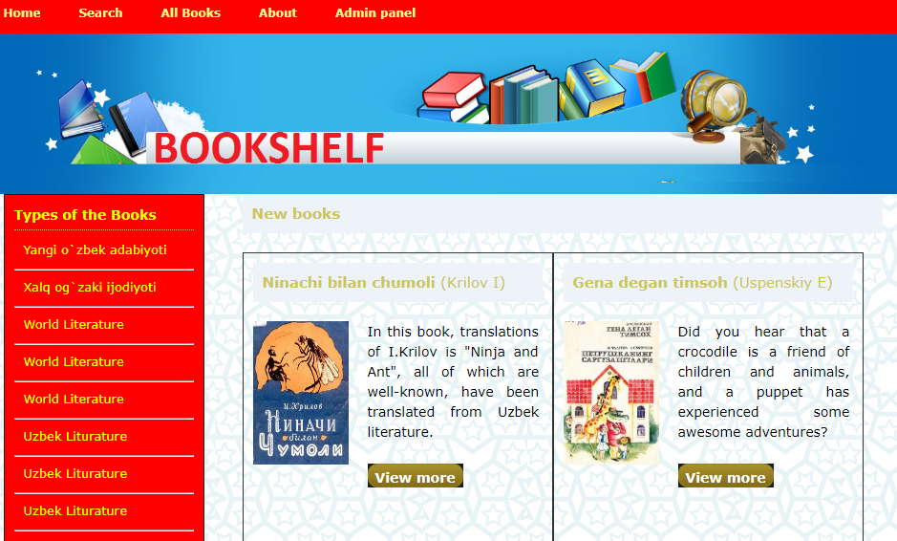
Figure 3. Appearance of home page
After creating the Home page we set other pages too. In the navigation part we created PHP pages. We added information and other things after adding tags and HTML codes and we checked.

Admin page
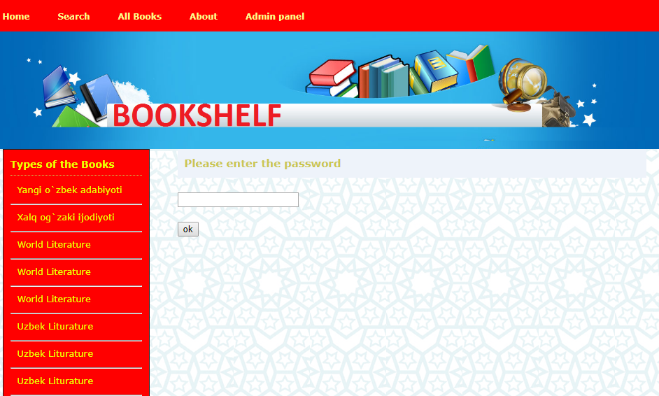
Figure 4. Admin page
This is our admin page. You need to enter password. The password is 1997.
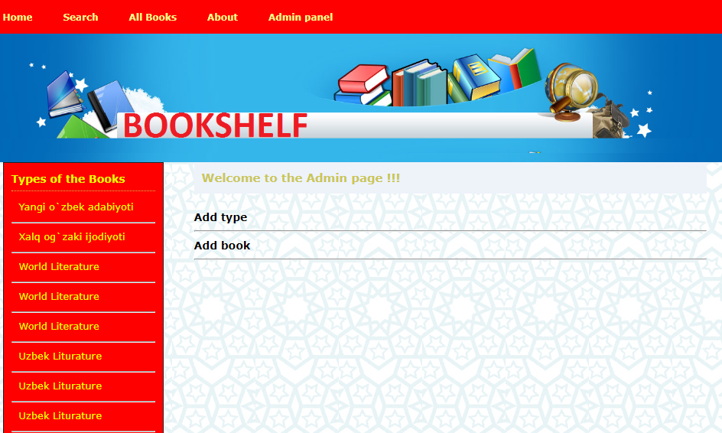
Figure 5. Admin panel
After entering the password, this page will be seen. As you see in this page admin can add new type of book and new book too.
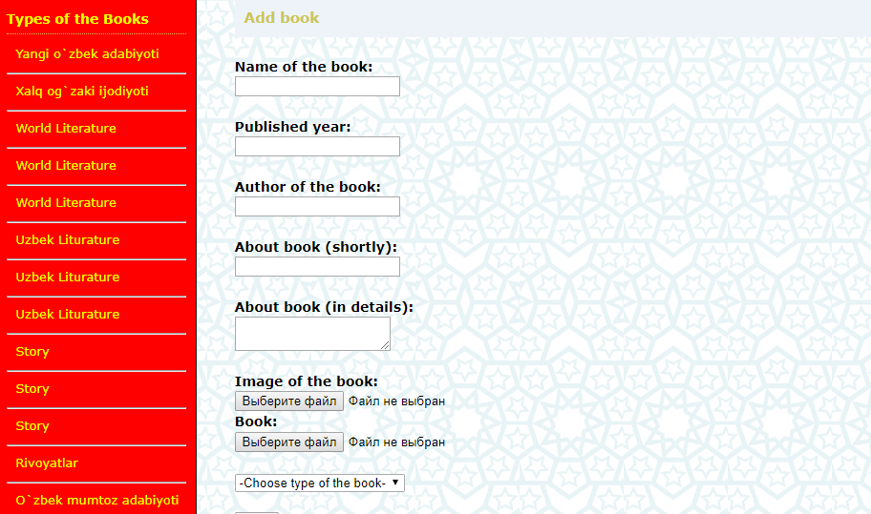
Figure 6. Add book page
As you see for saving new book you need to fill all fields. If any of them will not be filled the error message will appear.
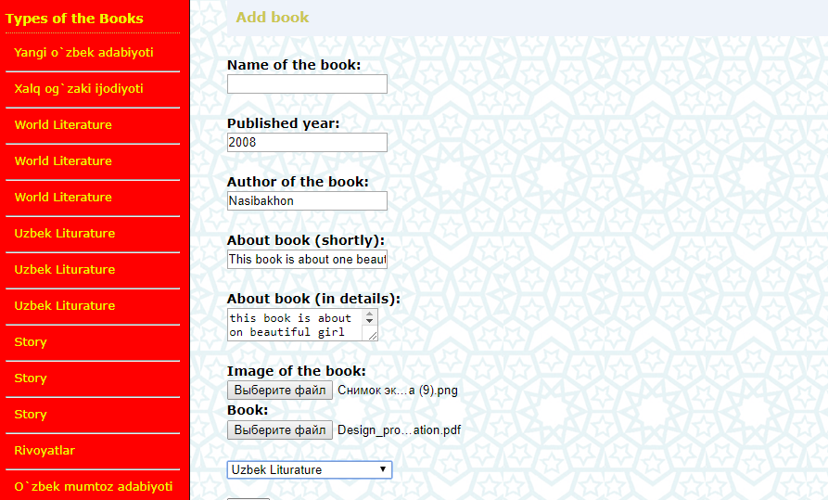
Figure 7. Add book page
Here you can see that I did not enter the name of the book.
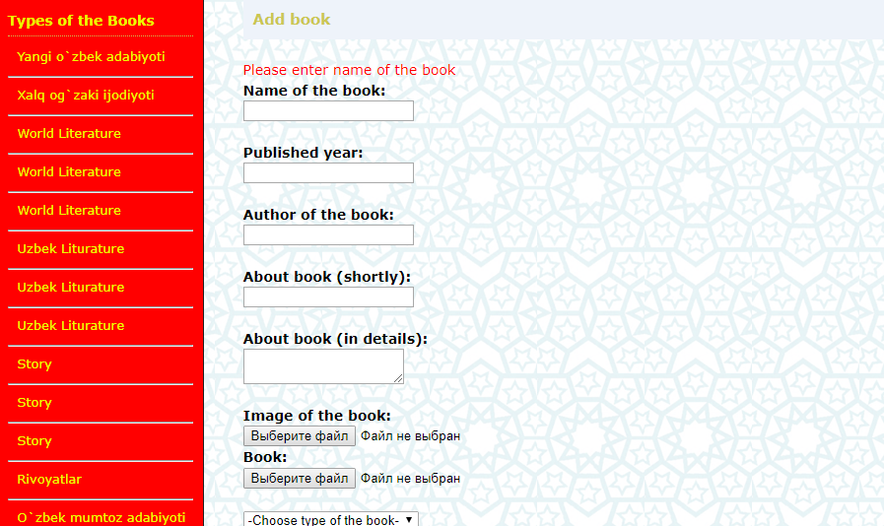
Figure 8. Add book page
And after pressing the button save this message will appear.

Search page
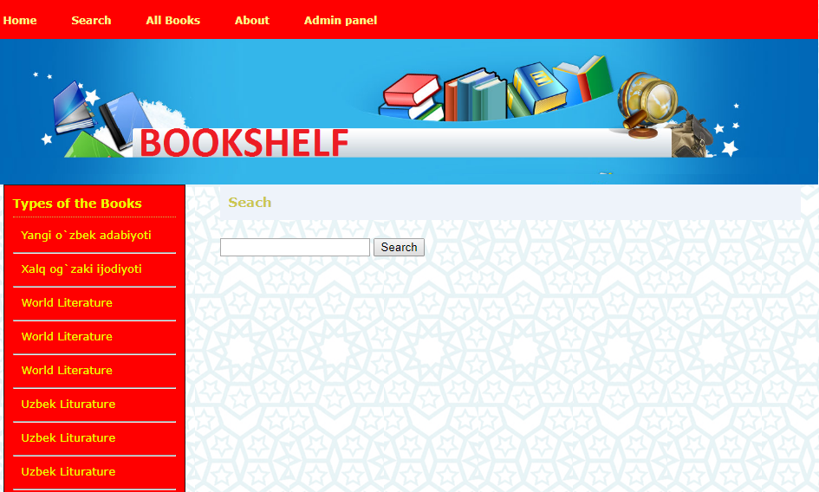
Figure 9. Search page
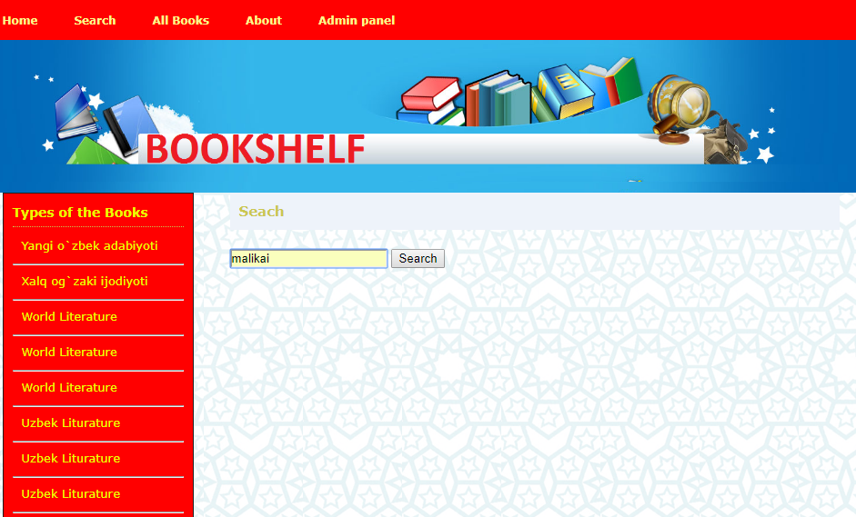
Figure 10. Search page
Here I input the name of the book which I want to find.

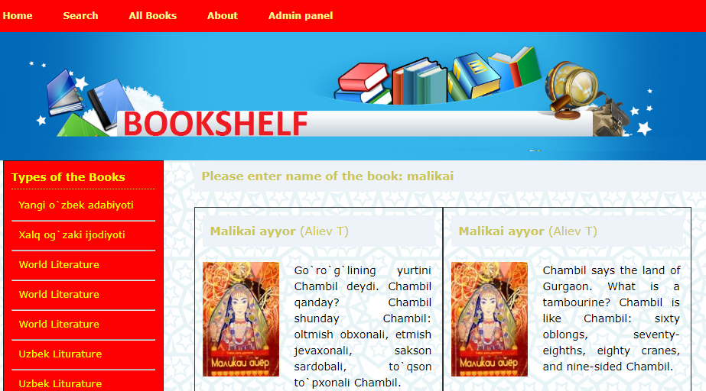
Figure 11. Search page
And after pressing the search button the book will be find.

ABOUT PAGE 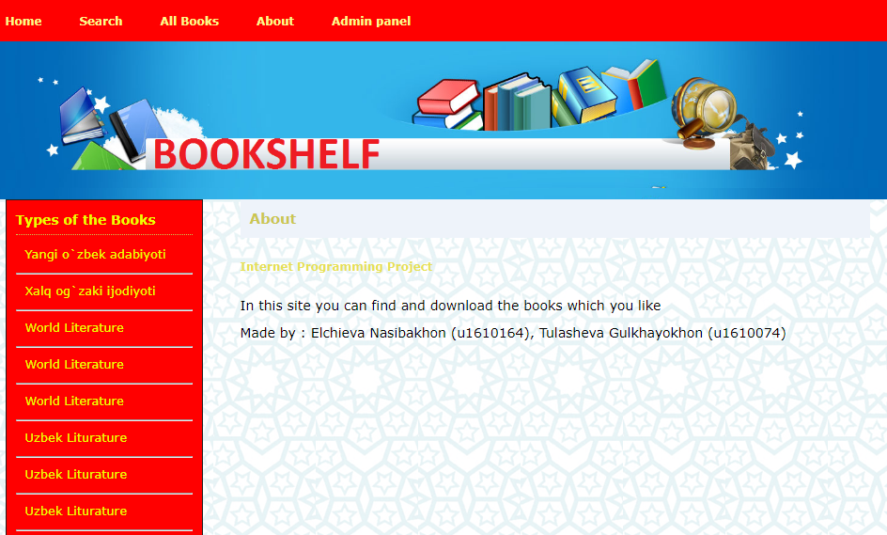
Figure 12. About page
In this page users can read all about us.

ALL BOOKS PAGE
Figure 13. All books page
In this page user can see all book which are unsorted and read short information.

URL Links to our remotely hosted web site and GitHub repository
https://github.com/iuthub/design-project-twin-2

References
- Денис Колисниченко “PHP и MySQL. Разработка Web-приложений”
- Николай Прохоренок “HTML, JavaScript, PHP и MySQL. Джентльменский набор Web-мастера”
- http://htmlbook.ru
- http://www.Bootstrap.com
- http://Code.org/jquery/styles
- http://php.net
- http://w3schools.com

